**ROLDA, Christine Mae B. Rolda**

BSIT-2 (BLOCK B)

**ACTIVITY: JS Operators**

* **Source Code (index.html):**

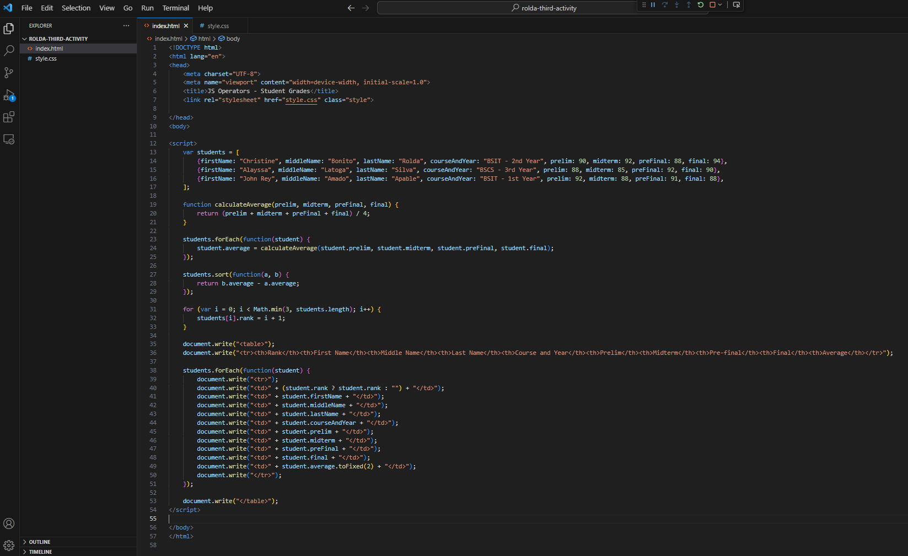

* **Source Code (style.css):**

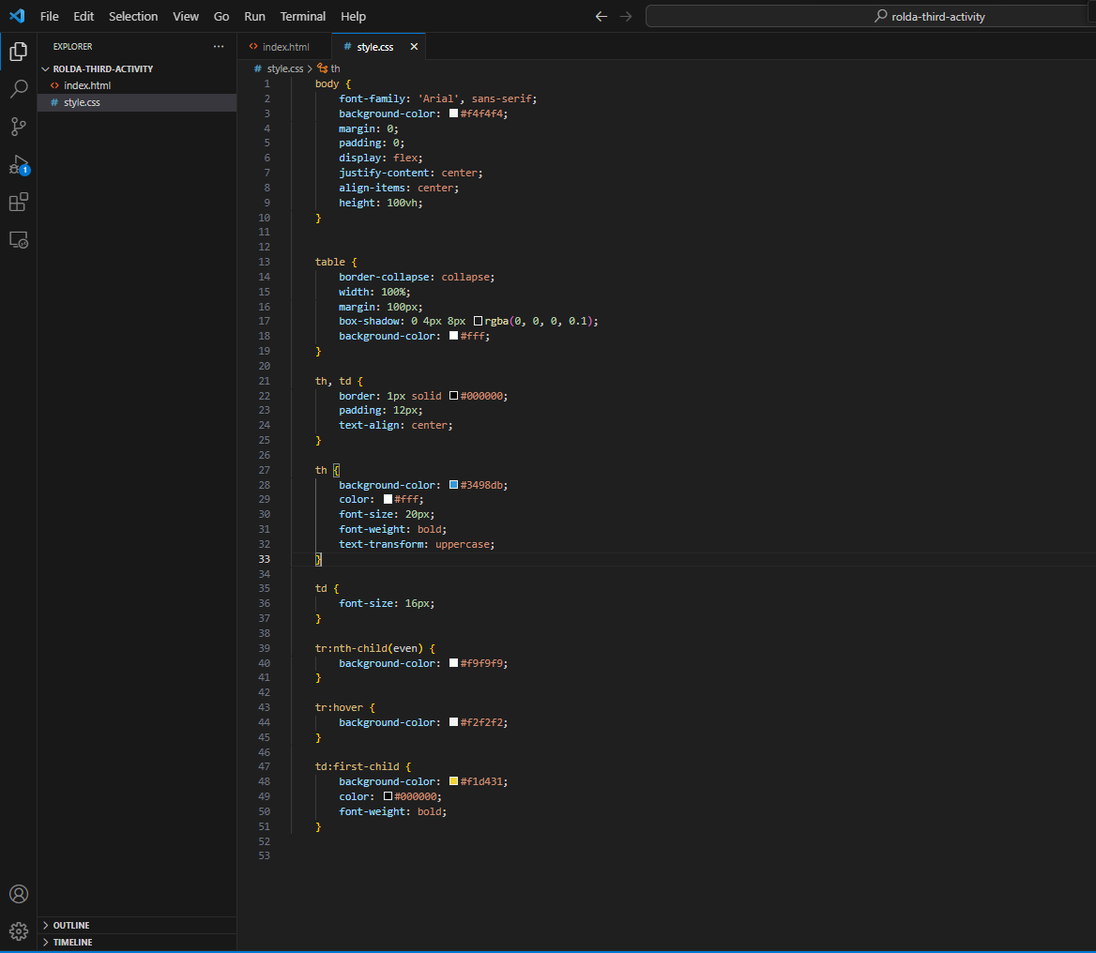

* **Output:**

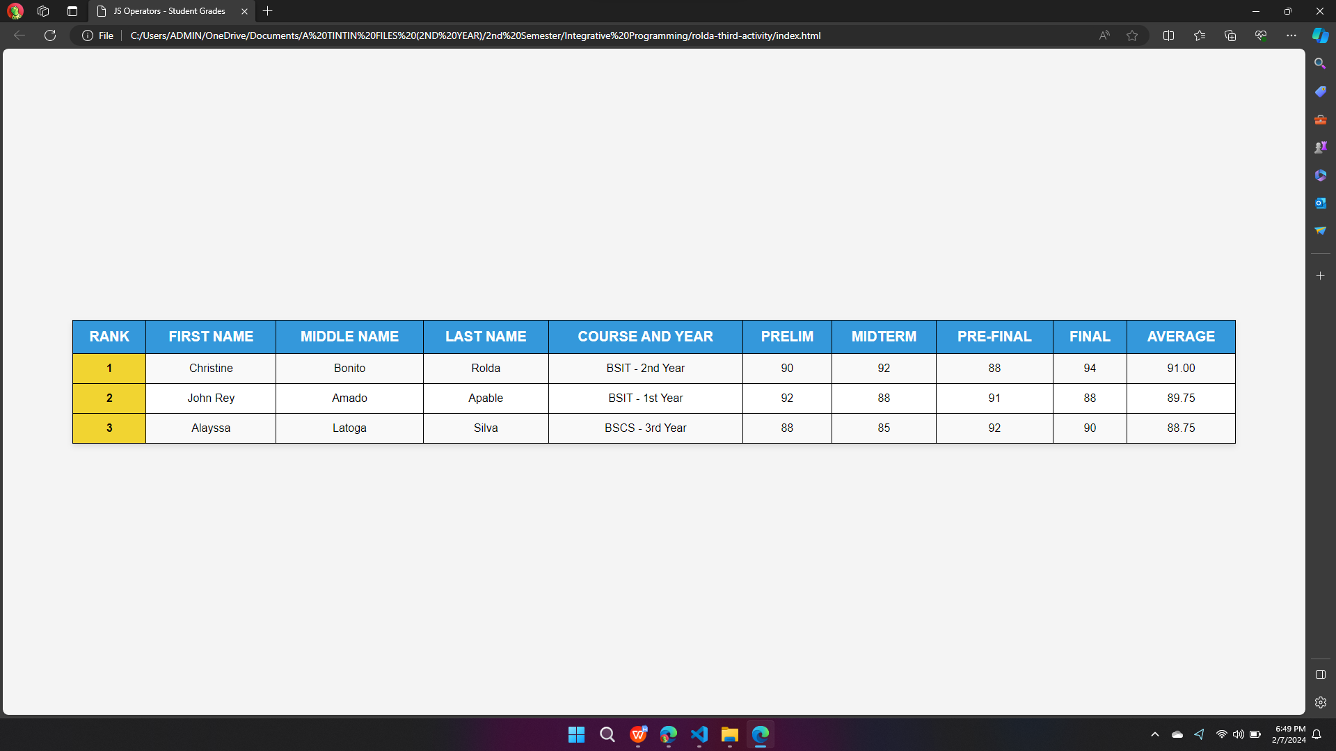

**FILES AND FOLDER UPLOADED TO GITHUB:**

**Link:** https://github.com/OmnimvO/array_functions.git

**ALL SOURCE CODES FOR JS OPERATORS:**

* **Source Code (index.html):**

<!DOCTYPE html>

<html lang="en">

<head>

<meta charset="UTF-8">

<meta name="viewport" content="width=device-width, initial-scale=1.0">

<title>JS Operators - Student Grades</title>

<link rel="stylesheet" href="style.css" class="style">

</head>

<body>

<script>

var students = [

{firstName: "Christine", middleName: "Bonito", lastName: "Rolda", courseAndYear: "BSIT - 2nd Year", prelim: 90, midterm: 92, preFinal: 88, final: 94},

{firstName: "Alayssa", middleName: "Latoga", lastName: "Silva", courseAndYear: "BSCS - 3rd Year", prelim: 88, midterm: 85, preFinal: 92, final: 90},

{firstName: "John Rey", middleName: "Amado", lastName: "Apable", courseAndYear: "BSIT - 1st Year", prelim: 92, midterm: 88, preFinal: 91, final: 88},

];

function calculateAverage(prelim, midterm, preFinal, final) {

return (prelim + midterm + preFinal + final) / 4;

}

students.forEach(function(student) {

student.average = calculateAverage(student.prelim, student.midterm, student.preFinal, student.final);

});

students.sort(function(a, b) {

return b.average - a.average;

});

for (var i = 0; i < Math.min(3, students.length); i++) {

students[i].rank = i + 1;

}

document.write("<table>");

document.write("<tr><th>Rank</th><th>First Name</th><th>Middle Name</th><th>Last Name</th><th>Course and Year</th><th>Prelim</th><th>Midterm</th><th>Pre-final</th><th>Final</th><th>Average</th></tr>");

students.forEach(function(student) {

document.write("<tr>");

document.write("<td>" + (student.rank ? student.rank : "") + "</td>");

document.write("<td>" + student.firstName + "</td>");

document.write("<td>" + student.middleName + "</td>");

document.write("<td>" + student.lastName + "</td>");

document.write("<td>" + student.courseAndYear + "</td>");

document.write("<td>" + student.prelim + "</td>");

document.write("<td>" + student.midterm + "</td>");

document.write("<td>" + student.preFinal + "</td>");

document.write("<td>" + student.final + "</td>");

document.write("<td>" + student.average.toFixed(2) + "</td>");

document.write("</tr>");

});

document.write("</table>");

</script>

</body>

</html>

* **Source Code (style.css):**

body {

font-family: 'Arial', sans-serif;

background-color: #f4f4f4;

margin: 0;

padding: 0;

display: flex;

justify-content: center;

align-items: center;

height: 100vh;

}

table {

border-collapse: collapse;

width: 100%;

margin: 100px;

box-shadow: 0 4px 8px rgba(0, 0, 0, 0.1);

background-color: #fff;

}

th, td {

border: 1px solid #000000;

padding: 12px;

text-align: center;

}

th {

background-color: #3498db;

color: #fff;

font-size: 20px;

font-weight: bold;

text-transform: uppercase;

}

td {

font-size: 16px;

}

tr:nth-child(even) {

background-color: #f9f9f9;

}

tr:hover {

background-color: #f2f2f2;

}

td:first-child {

background-color: #f1d431;

color: #000000;

font-weight: bold;

}